**3 The Graphics Processing Unit**

**3.1 Data-Parallel Architectures**(**TODO**)

SIMD: single instruction, multiple data.

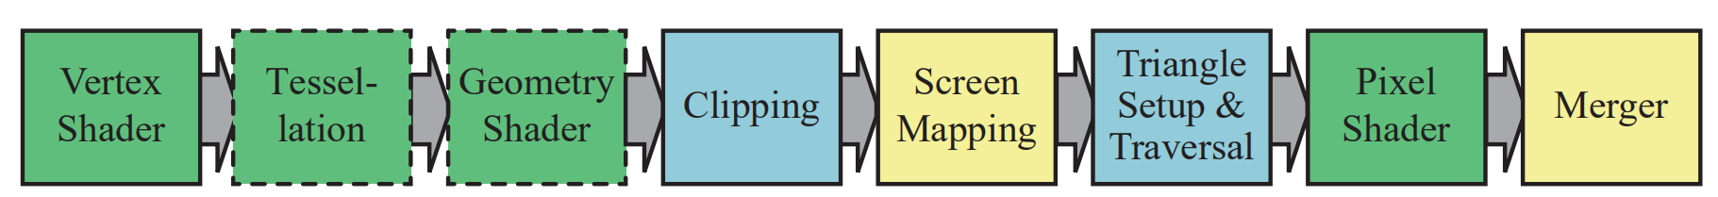

**3.2 GPU Pipeline Overview**

**3.3 The Programmable Shader Stage(TODO)**

**3.4 The Evolution of Programmable Shading and APIs**

DirectX, OpenGL, OpenGL ES, WebGL, Metal, Vulkan.

**3.5 The Vertex Shader**

**3.6 The Tessellation Stage**

